Performance Analysis of Different Neural Networks for Sentiment Analysis on IMDb Movie Reviews

21K-3153

Objective:

With the exponential growth of text data, sentiment analysis has become a crucial tool for understanding user opinions about various entities such as products, companies, or services. This project focuses on analyzing IMDb movie reviews using different neural network architectures to determine the most effective model for sentiment classification. We aim to:

• compare the performance of Convolutional Neural Networks (CNN), Long Short-Term Memory Networks (LSTM), and a hybrid LSTM-CNN architecture.

• identify the best-suited neural network architecture for sentiment analysis on the IMDb movie reviews dataset.

Dataset:

The dataset used is the IMDb movie review dataset, which contains 50,000 reviews labeled as either positive or negative. The dataset was split into 70% for training and 30% for testing. Each review was standardized to a fixed length through zero-padding.

Preprocessing:

Each word in the reviews was converted into a 100-dimensional vector using an embedding layer. We utilized a pre-trained GloVe model, comprising 6 billion words, with each word represented by a 100-dimensional vector.

**Model Architectures**

* **Convolutional Neural Network (CNN):** The CNN model was employed for its strength in detecting local features within the text. It consisted of two convolutional layers, with a 1D Max Pooling between them to reduce dimensionality. A GlobalMaxPooling layer was then applied to identify the most significant feature. The ReLU activation function was used throughout, with a sigmoid activation function in the final output layer for binary classification. 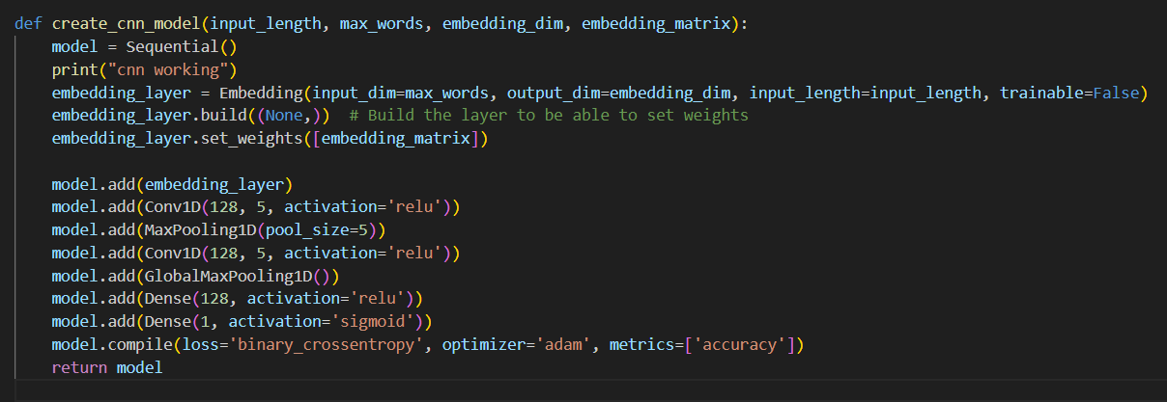CNN RESULTS:

We observe an accuracy of 86% for our CNN model.

* **Long Short-Term Memory (LSTM):** The LSTM model was specifically designed to capture long-term dependencies and contextual information within the text. This architecture included a single LSTM layer with 200 units, allowing it to effectively remember and utilize information from earlier parts of the text. LSTMs achieve this by using a series of gates: the input gate controls the extent to which new information flows into the cell, the forget gate determines what information from the cell state should be discarded, and the output gate regulates what information from the cell state is passed to the next hidden state. The output from the LSTM layer was then fed into a Multi-Layer Perceptron (MLP), which served as the classifier. The MLP, consisting of one or more dense layers, processed the extracted features from the LSTM layer to perform the final sentiment classification. This combination enabled the model to leverage both the sequential patterns in the text and the learned feature representations for accurate classification.

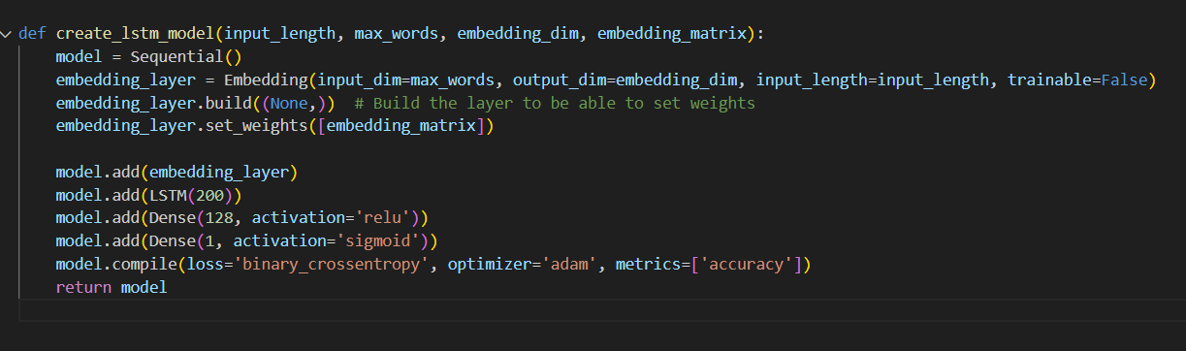

LSTM Results:

We observe an accuracy of 89%

* A screenshot of a computer

  Description automatically generated

**LSTM-CNN:** This hybrid model synergistically combined the strengths of LSTM and CNN architectures to leverage both sequential dependencies and local feature detection. The architecture began with an LSTM layer, which effectively captured long-term dependencies and contextual information within the text through its gating mechanisms: the input gate, forget gate, and output gate. Following the LSTM layer, the output sequences were passed to a series of convolutional layers. These convolutional layers, equipped with filters, detected local patterns and features within the sequential data.

Subsequently, 1D Max Pooling layers were applied to reduce the dimensionality of the feature maps, retaining the most significant features while reducing computational complexity. This was followed by a GlobalMaxPooling layer, which identified the most prominent features across the entire text. Finally, the processed features were fed into a fully connected layer, which performed the final sentiment classification. The ReLU activation function was used throughout the network to introduce non-linearity, and a sigmoid activation function was employed in the final output layer for binary classification. This comprehensive architecture aimed to harness the strengths of both LSTM and CNN for more accurate and robust sentiment analysis.

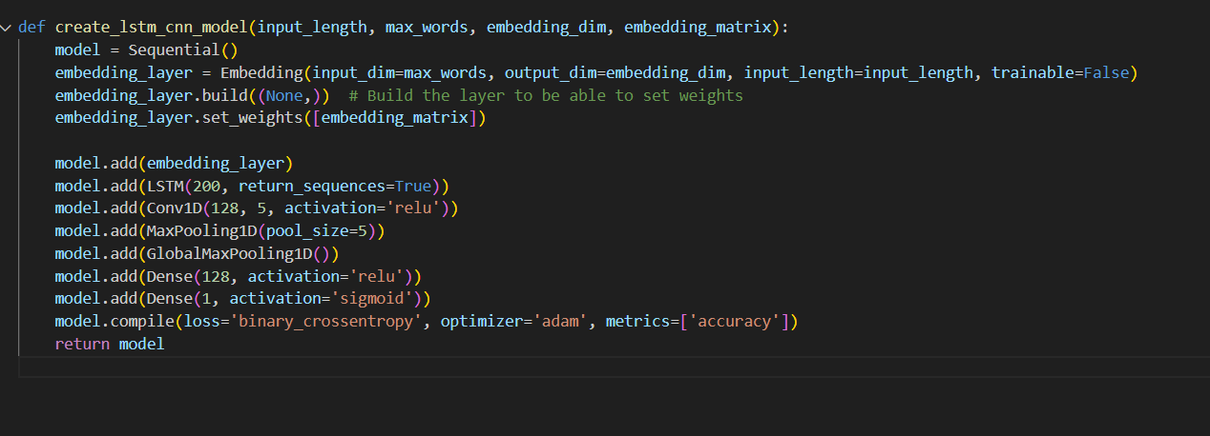

LSTM – CNN results:

We observe an accuracy of 87%

Conclusion:

In the performance analysis of the IMDb movie reviews dataset, the LSTM model outperformed with 89% accuracy, benefiting from its ability to capture long-term dependencies and contextual nuances, which are vital for sentiment analysis. The CNN model, achieving 86% accuracy, is effective at detecting local patterns but struggles to capture the broader contextual relationships in longer text segments. The LSTM-CNN hybrid model, which combines both architectures, reached 87% accuracy, suggesting a blend of strengths but not surpassing the LSTM model. This indicates that the dataset's complexity and the specific nature of sentiment cues are well-suited to the strengths of LSTMs, which excel in understanding the sequential and contextual aspects of text, thereby performing better in sentiment analysis tasks.